Book Library Website Requirements

Landing page

1. Need to change look and feel of default landing page, it should look something like Justbooks or doorstep at books (Preference).
2. In the home page we should have how it works page
   1. <http://www.doorstepbooks.com/index.php?view=howitwork>

Queries : Can you describe in more details about your membership plan? OR your menbership plan will be similar like door step membership plan. Please let us know.

Queries : Can you tell me about “Add to Booklist” features?We observed that after successful registration of a member ,he will able to add book to the “Booklist”.Then from the Booklist he will request these books for reading .But my question is

Is there any restriction in number of requesting books for a member?

Queries : If a member registered in 6 months plan. Let the user does not return the books after 6 months.Then what happen?

Queries : What is the return process of requesting books?

Queries : Which payment fateway do yiu want to integrate?

Queries : Suppose a user registered registered in 3 months plan.The plan expiry after 3 months.Then what happen?

1. In the home page we should have subscription feature like below and we need to add location drop down (required field) as well.



1. In the home page we should have FAQ page<https://www.justbooks.in/faq>
2. In the home page we should have categories page

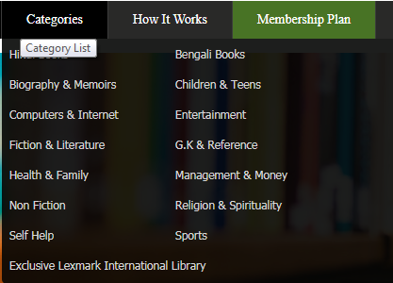

1. In the home page we should have donate book contact form.
   1. http://www.doorstepbooks.com/index.php?view=donate_book

Member: After login:

1. User should able to see the books based on categories and there he should have a button add to book list.

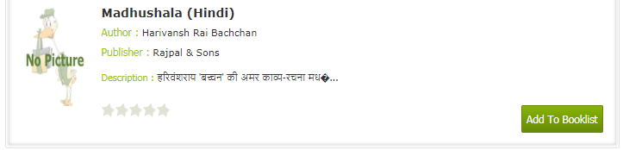

1. If the user already read the book before, user should get an alert saying that you have already completed reading this book.

Queries : How the system will know user had already read this book?I think when an user return a book means, he had read this book.If you have any other ideas please suggest.

1. From the book list either admin able to see the books or admin has to receive the mail
2. Once we deliver the book the book should not be in users book list, it should be either in currently reading or my past records.

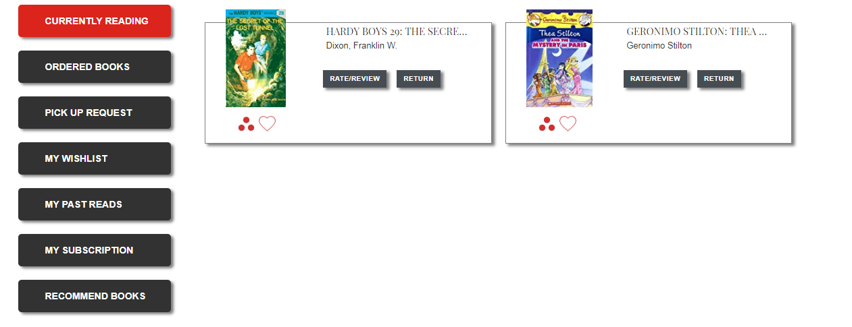

1. My subscription page should have

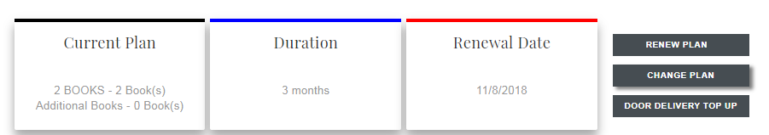

**Queries : Can you tell me which plans do you want to keep at the time of registration?We also want to know about your “Door Delivery top up” features.**

**Queries : What is your receive process of books from the users?**

**Queries : What is your recommend books concept?Please describe in more details.**

Admin:

1. Admin should able to see/take print out of users wish list along with address and phone number.
2. Admin should able to get user subscription details and due details.

Plugins may help:

### [Paid Memberships Pro — WordPress Plugins](https://wordpress.org/plugins/paid-memberships-pro/)

### YITH WooCommerceWishlist